**EXPERIMENT 4**

**STATIONARY CHECK OF IN TIME SERIES DATA**

**AIM:**

To implement a program that checks the stationarity of a time series dataset using statistical methods and visualization techniques.

**ALGORITHM:**

1. Import necessary libraries.

1. Prompt the user to upload a dataset file.

1. Load the dataset into a Pandas DataFrame.

1. Display column names and ask for the date column name.

1. Parse the date column and set it as an index (if applicable).

1. Ask the user to select a target column for time series analysis.

1. Visualize the time series data using line plots.

1. Compute rolling mean and standard deviation to check trends.

1. Perform the Augmented Dickey-Fuller (ADF) Testto check for stationarity.

1. Display results and interpretation.

**CODE:**

# Import necessary libraries import pandas as pd import numpy as np import matplotlib.pyplot as plt import seaborn as sns

from statsmodels.tsa.stattools import adfuller from google.colab import files

import io

# Prompt user to upload the dataset print("Please upload your dataset (CSV file).") uploaded = files.upload()

# Get the uploaded filename filename = list(uploaded.keys())[0] print(f"Uploaded file: {filename}")

# Load dataset without parsing dates first df = pd.read_csv(io.BytesIO(uploaded[filename]))

# Display column names print("\nColumn names in the dataset:", df.columns.tolist())

# Ask user for the date column name date_column = input("\nEnter the column name for the date (or press Enter if no date column): ").strip()

# If a date column is provided, parse it as an index if date_column and date_column in df.columns:

df[date_column] = pd.to_datetime(df[date_column]) # Convert to datetime format

df.set_index(date_column, inplace=True) # Set as index

print(f"\n'{date_column}' column set as index.") else:

print("\nNo date column provided or found. Using default index.")

# Display first few rows print("\nFirst few rows of the dataset:") print(df.head())

# Ask user for the time-series column name column_name = input("\nEnter the column name for time-series analysis (e.g., Temperature): ").strip()

# Check if column exists if column_name not in df.columns:

print(f"\nError: Column '{column_name}' not found in dataset.") else:

# Extract time series data

ts = df[column_name]

# Plot the original time series

plt.figure(figsize=(12,6))

plt.plot(ts, label="Original Time Series")

plt.title(f"{column_name} Time Series Data")

plt.xlabel("Time")

plt.ylabel(column_name)

plt.legend()

plt.show()

**O/P:**

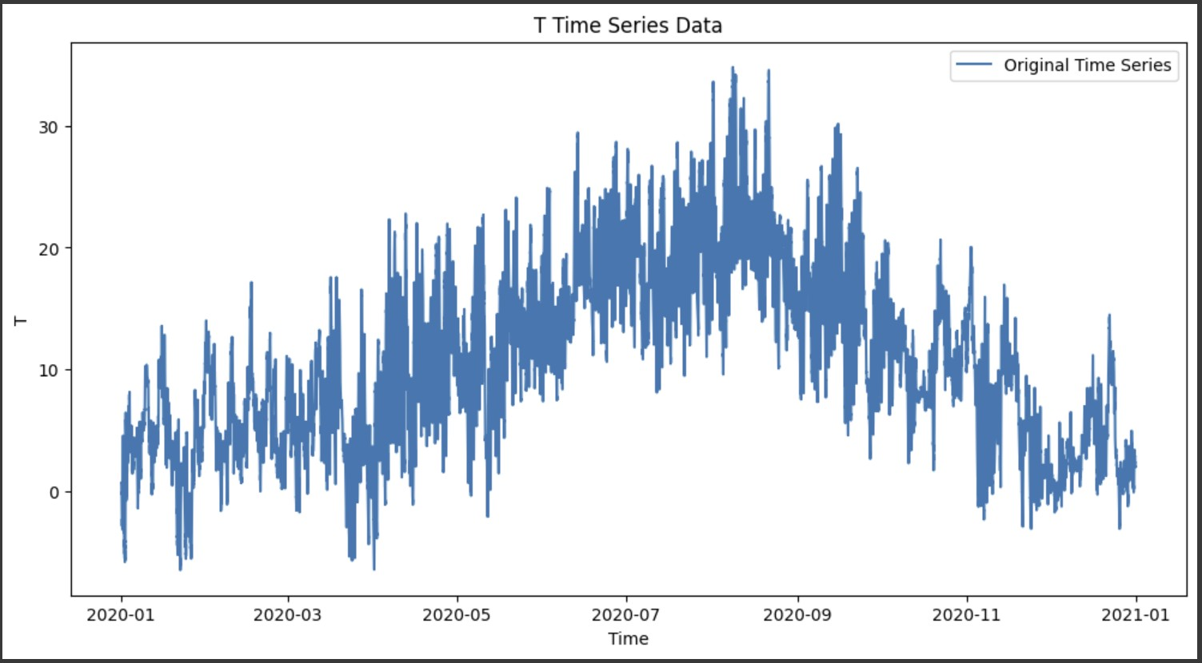

# Rolling statistics (Moving Average & Standard Deviation)

rolling_window = 12 # Choose a window size

rolmean = ts.rolling(window=rolling_window).mean()

rolstd = ts.rolling(window=rolling_window).std()

# Plot rolling statistics

plt.figure(figsize=(12,6))

plt.plot(ts, color="blue", label="Original")

plt.plot(rolmean, color="red", label="Rolling Mean")

plt.plot(rolstd, color="black", label="Rolling Std Dev")

plt.title("Rolling Mean & Standard Deviation")

plt.legend()

plt.show()

**O/P:**

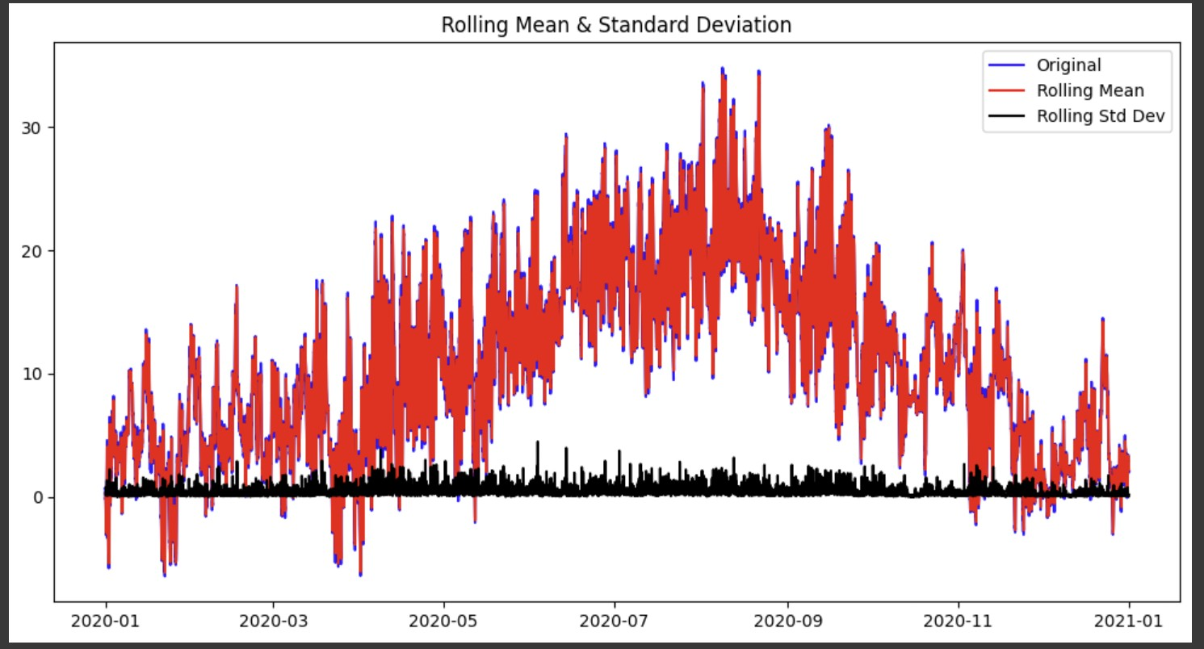

# Perform Augmented Dickey-Fuller Test def adf_test(timeseries):

print("\nResults of Augmented Dickey-Fuller Test:")

adf_result = adfuller(timeseries.dropna()) # Drop NaN values

labels = ["Test Statistic", "p-value", "#Lags Used", "Number of Observations Used"] for value, label in zip(adf_result[:4], labels):

print(f"{label}: {value}")

print("\nCritical Values:")

for key, value in adf_result[4].items():

print(f"\t{key}: {value}")

# Check stationarity

if adf_result[1] <= 0.05:

print("\nConclusion: The time series is STATIONARY (p-value <= 0.05)")

else:

print("\nConclusion: The time series is NON-STATIONARY (p-value > 0.05)")

# Run ADF test

adf_test(ts)

**O/P:**

Results of Augmented Dickey-Fuller Test:

Test Statistic: -8.407443757648588

p-value: 2.1485277355859027e-13

#Lags Used: 58

Number of Observations Used: 52637

Critical Values:

1%: -3.43047423996295

5%: -2.8615949115726993

10%: -2.5667992276035014

Conclusion: The time series is STATIONARY (p-value <= 0.05)

**RESULT:**

The program successfully analyzed the stationarity of the time series dataset.